

Registration Form



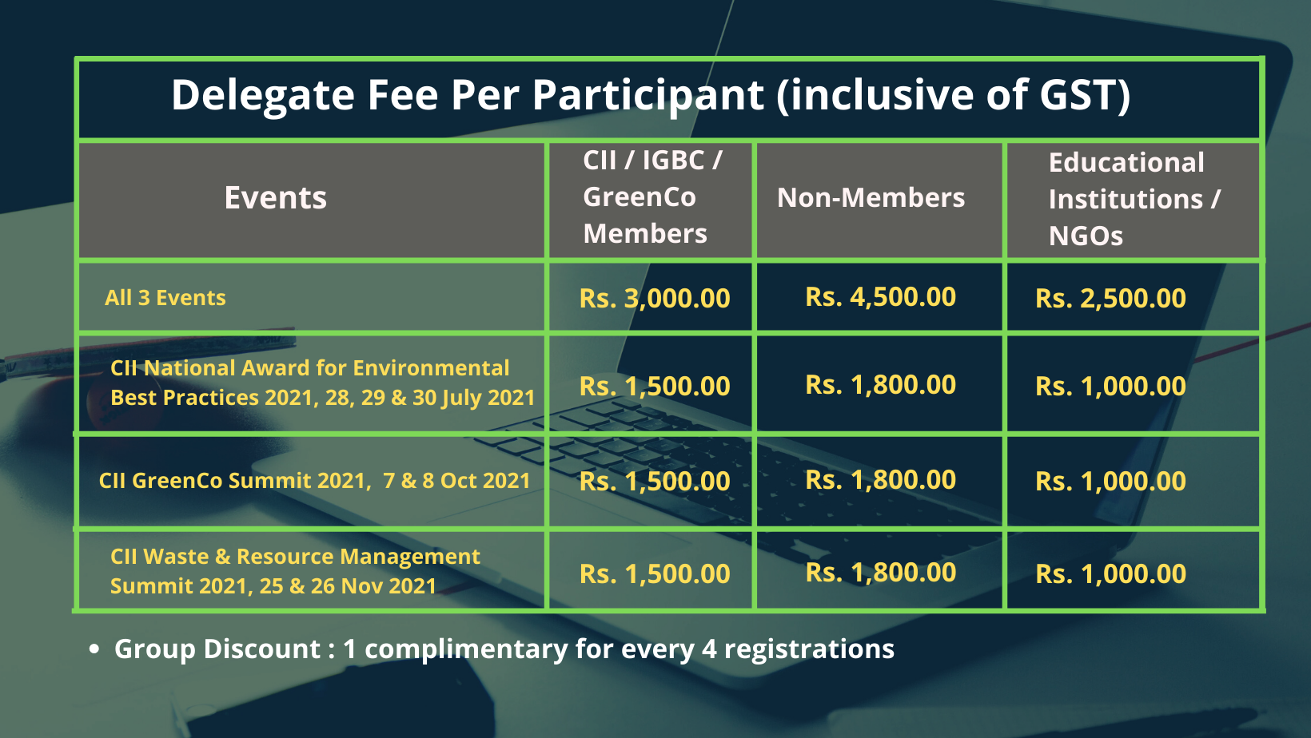

We are pleased to nominate the following participant (s) for the Event;

Sl.No. | Name | Designation | Email | Mobile | Name(s) of the conference attending | Delegate fee  (Rs.)
1
2
3
4
5 |  |  |  |  |  | Complimentary
 |  |  |  |  | Total (Rs)

Nominated / Registered by:
Name:_____________________________________ Organisation: ________________________________ Membership No:__________________
Company GSTIN No: ____________ Address:________________________________________________ ________________City:______________ Tel:____________________________Email:______________________________
NOTE: The same address will reflect in the invoice as mentioned above and no change is accepted after the invoice is generated

E-mail your filled-in registration form to:
DPV Suresh
CII – Sohrabji Godrej Green Business Centre, Confederation of Indian Industry, Survey No. 64, Kothaguda Post, Near HITEC City, Hyderabad – 500084
Ph: +91-40-44185165, Email: suresh.dpv@cii.in

- Delegate Fee is inclusive of GST
- Delegate fee is non-refundable but change in nomination is accepted
- Prior Payment is mandatory to confirm the delegate registration

Online Payment Details

- Payee Account Number - _________________
- Payee Name - ________________
- Amount - ____________________
- Date of Payment - ________________

** Please email online payment slip post payment

NEFT/ RTGS details:
- Account Holder Name: Confederation of Indian Industry
- Bank Name and Address: ICICI Bank Ltd: Door No 2-92-2/9, Stone Ridge Center, Opposite Google, Main Road, Kondapur, Hyderabad Telangana, 500 033
- Beneficiary Bank Account Number: 004005011896
- Branch Code: 0040
- MICR Code: 500229003
- IFSC /NEFT code: ICIC0000040
- PAN NO: AAATC0188R
- GST No: 36AAATC0188R1ZA

